


Brief Recordkeeping Overview Presentation Script

Slide 1 - OSHA Recordkeeping
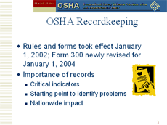
This program discusses the provisions of OSHA’s Recordkeeping Rule and incorporates the following changes effective January 1, 2004:
- Section 1904.12, Recording criteria for cases involving work-related musculoskeletal disorders, is deleted.
- The requirement in section 1904.29(b)(7)(vi) stating that MSD injuries and illnesses are not to be considered privacy concern cases is deleted.
- A column for recording hearing loss cases has been added to the OSHA Form 300 log.
- An entry for hearing loss cases has been added to the OSHA Form 300A Summary.[Employers should use the old 300A Summary Form (without the hearing loss entry) to post as required in February 2004. The new 300A form that includes the hearing loss entry should be used to post in February 2005.]
Presenter's Note: Prior to the presentation, it is suggested that presenters review the latest information on the recordkeeping rule. In addition, presenters should print copies of OSHA's main Recordkeeping page as a handout to inform audience members of the latest information available on the website.
Script:
- OSHA has a new, improved set of rules for recordkeeping. These new requirements - Part 1904 of 29CFR - took effect January 1, 2002.
- Injury and illness records are critical indicators - both for employers and for OSHA. They tell us how we're doing in our efforts to keep workers safe. They pinpoint weaknesses - breakdowns in machinery, inadequate personal protective equipment, failures in communication, insufficient training. When a worker gets sick or hurt, something has gone wrong. And employers need to look at these cases to see if they can take action to prevent future problems.
- But there is also great value in reviewing the records as a whole to identify patterns and trends. What's happening in specific departments and across the facility? How does your injury and illness experience stack up against others in your industry? Is it clear that your employees understand the need to wear protective equipment and follow safety rules? Asking these questions - and taking action in response to the answers - can prevent future injuries and illnesses and improve a company's bottom line. Whenever OSHA visits a workplace, injury and illness records are the first thing the inspectors want to see. These records give us a starting point to identify where problems may lie. Of course, if a company has been tracking its experience and addressing these issues, what we may find is that the site has corrected hazards and resolved concerns.
- In addition, each year about 80,000 sites in high-hazard industries are asked to send injury and illness data directly to OSHA. This gives us an opportunity to track data directly and identify individual sites that need to improve.
- Records are important beyond individual establishments. We need to know how we're doing collectively - the entire U.S. workforce. We need to find out where the problems are so we can work to address them. The Bureau of Labor Statistics surveys about 200,000 employers - of all sizes and in all industries - to develop the national estimate of workplace injuries and illnesses issued every December.

Slide 2 - Recordkeeping History
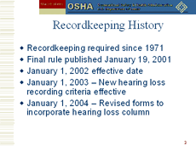
Script:
- OSHA has required employers to keep injury and illness records since 1971, the year the agency was formed. This is the first major effort to improve the system established 30 years ago. Under the new rule, about 1.4 million sites will maintain injury and illness records.
- The final rule was published on January 19, 2001.
- The recordkeeping rule went into effect as scheduled on January 1, 2002, with two exceptions: requirements for recording hearing loss and defining musculoskeletal disorders (MSDs).
- On July 1, 2002, OSHA issued a final rule that revised the criteria for recording work-related hearing loss. Beginning January 1, 2003, you record a case when a hearing test reveals that an employee has experienced a work-related Standard Threshold Shift (STS) in one or both ears and the employee's total hearing level is 25 dB or more above audiometric zero in the same ear as the STS. Forms revised for use January 1, 2004 include a hearing loss column.
- Also on July 1, 2002, the Agency asked for public comment on a delay for the definition of musculoskeletal disorders (MSDs) and whether to include a separate column for MSDs on the OSHA 300 Log. Based on comments received, OSHA has decided not to include the separate MSD column and ¶ 1904.12 has been deleted. The deletion has no effect on an employer's obligation to record all cases meeting the requirements of ¶ 1904.4-1904.7. If a musculoskeletal disorder is work-related, and is a new case, and meets one or more of the general recording criteria, it must be recorded.
- As noted earlier in this presentation, employers must begin to use the new OSHA Form 300 on January 1, 2004. The new 300A form that includes the hearing loss column should be used to post in February, 2005.

Slide 3 - Recordkeeping Goals
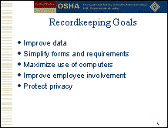
Script:
- In revising the rule, OSHA had several goals: improve the data, make recordkeeping simpler for employers, maximize the use of computers and technology, improve employee involvement and protect the privacy of the injured or ill worker.

Slide 4 - Am I Covered?
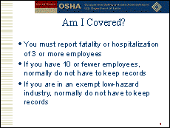
Presenter's Note: Provide handout on Partially Exempt Industries.
Script:
- When it comes to OSHA recordkeeping, the first question an employer needs to ask is: Am I covered? Every employer - regardless of size or industry - must orally report any incident that involves the death of a worker and/or the hospitalization of three or more workers. You must call your local OSHA office or 1-800-321-OSHA within eight hours. You don't have to report most highway or commercial carrier accidents, but you must report fatal heart attacks that occur at work. [§1904.39]
- If you have 10 or fewer workers, you normally do not need to keep injury and illness records. Remember to include temporary employees under your direct supervision in that count. And if you're in one of the exempt low-hazard industries, you don't have to keep records unless OSHA or BLS asks you to participate in their annual surveys. [§1904.1 & §1904.2]

Slide 5 - What is Recordable?
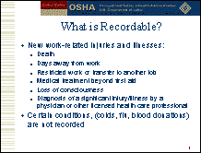
Script:
- Second, you need to know what to count. The injuries and illnesses you record must be new cases that are work-related. That includes pre-existing conditions that are significantly aggravated by workplace events or exposures. [§1904.4 & §1904.5]
- What do you actually record? Injuries and illnesses that result in:
- Death
- Days away from work
- Restricted work or transfer to another job
- Medical treatment beyond first aid
- Loss of consciousness
- Significant injury or illness diagnosed by a physician or other licensed healthcare professional. [§1904.7]
- We've also got a new list of exceptions - problems not considered work-related. The rule makes it clear that employers don't have to record cases involving eating and drinking food and beverages, common colds and flu, blood donations, and exercise programs. In addition, mental illness will not be recorded unless the employee voluntarily provides the employer with an opinion from an appropriate licensed healthcare professional stating that the employee's mental illness is work-related. But some injuries to employees doing work at home or while traveling on business are counted. [§1904.5]

Slide 6 - Other New Elements
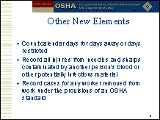
Script:
- What you don't record are injuries or illnesses treated through first aid - such as taking aspirin, getting a tetanus shot, applying a butterfly bandage, draining a blister, wearing a finger guard, etc. For recordkeeping purposes, first aid cases are not recordable. The rule provides an absolute list of what is first aid. If a treatment is NOT on the list, it MUST be considered medical treatment. [§1904.7(b)(5)(ii)]
- We're also making it simple when it comes to counting days away from work or days of restricted work activity - just count calendar days. This will make the counts more consistent and make the actual length of an injury or illness clear. [§1904.7(b)(3)]
- Employers need to record all injuries from needles and sharps that are contaminated by another person's blood or other potentially infectious material, not just those that lead to illness. They'll also record a case for any worker removed from work under the provisions of an OSHA standard - such as lead. The new rule also makes it clear that work-related cases of tuberculosis should be recorded. [§1904.8; §1904.9; §1904.11]

Slide 7 - Forms
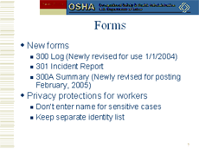
Script:
- Let's talk about the new forms. There are three: the 300 log, which replaces form 200; 301, which replaces 101; and 300A, a separate form to use to display the annual summary. [§1904.29]
- The 300 log is a listing of all the injuries and illnesses at your site. You can maintain it on a computer or at another location as long as you can produce a copy at the workplace whenever it's needed. You have seven calendar days to fill in the form once you learn of a case.
- The 301 form is the individual record of a work-related injury or illness. You'll fill out a new form for each case - again within seven calendar days. You can use an equivalent form if you prefer.
- Form 300A is the summary of work-related injuries and illnesses. This is the one you post every year. The new rule requires a three-month posting - February 1 to April 30. The summary must be certified by a company executive - the owner, an officer of the corporation, the highest ranking company official working at that site, or his or her supervisor. Top management needs to be aware of the injury and illness experience of the site and verify that the records are accurate. [§1904.32]
- With the new forms come new privacy protections for workers. You won't enter the name of workers for sensitive cases such as injuries or illnesses involving an intimate body part or the reproductive system, sexual assault, HIV or hepatitis infection, tuberculosis, mental illness or other similar cases. You do need to keep a separate, confidential identity list for these cases. Regardless of the injury or illness, if you share your records with anyone not authorized by the rule to see them, you must remove employee names before doing so. [§1904.29]
- OSHA recordkeeping forms must be kept for five years following the year they cover. During that time you need to update the OSHA 300 form to include newly discovered cases or to show changes in old cases. You do not have to update the 301 and 300A forms. Be sure to transfer the recordkeeping forms if you sell your business. [§1904.33 & §1904.34]
- There are some additional considerations. Temporary workers and contract workers, for example. You must record their injuries and illnesses the same as any other worker on your payroll, if you are supervising their work. [§1904.31(b)(2)]

Slide 8 - Employee Involvement
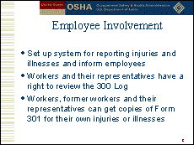
Script:
- To be sure your records are complete, you must tell each employee how to report a work-related injury or illness. This means setting up a reporting system and informing each worker of the system. [§1904.35]
- Workers and their representatives have a right to review the 300 log - no later than the end of the next business day - with all the names on it, (except, of course, the names for the privacy concern cases). Workers, former workers or personal representatives must be able to get copies of Form 301 covering their own injuries or illnesses by the end of the next business day. Authorized representatives can have access to just the "information about the case" section of any or all 301 forms within seven calendar days. You must provide records within four business hours to authorized government representatives such as OSHA inspectors or NIOSH investigators. [§1904.35 & §1904.40]

Slide 9 - State Programs
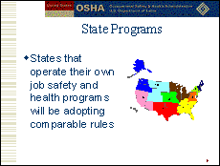
Script:
- States that operate their own job safety and health programs have adopted comparable recordkeeping rules that were also effective January 1, 2002. It's important in compiling national statistics that all employers use the same criteria for injuries and illnesses. For other recordkeeping provisions, for example, industry exemptions, state requirements may be more stringent than federal requirements.

Slide 10 - For More Information
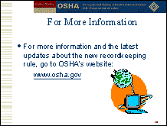
Presenter's Note: Provide handout on most recent OSHA Recordkeeping Page from the OSHA website.
Script:
- This system is a big improvement over the old - for everyone. Better records will help us better track injuries and illnesses and identify hazards that need further attention. Both workers and employers will benefit.

