

Region IV
Compliance Assistance Outreach


Construction
Topics

Ladder Safety
Hazards: Broken or missing parts, used around energized electrical equipment, too short for work height, weight limit rating too low, not the correct equipment for job
Loads: Self-supporting (foldout) and non-self-supporting (leaning) portable ladders able to support at least four times the maximum intended load; extra-heavy-duty metal or plastic ladders able to sustain 3.3 times the maximum intended load

Angle: Non-self-supporting ladders positioned with a horizontal distance from the top support to the foot of the ladder is about 1/4 the working length of the ladder; job-made wooden ladders positioned with an angle equal to about 1/8 the working length
Rung: Rungs, cleats, or steps must be parallel, level, and uniformly spaced and must be spaced between 10 and 14 inches apart; extension trestle ladders, the spacing must be 8-18 inches for the base, and 6-12 inches on the extension section, shaped so that an employee's foot cannot slide off, skid-resistant
Storage: Store where ladders cannot be damaged, prevent warping or sagging, secure during transport
Inspection: Check to ensure shoes and ladder are free of oil, grease, wet paint, and other slipping hazards; warning labels are legible; spreader device can be locked in place and ensure area around the top and bottom of ladder is cleared of material.
Safe Practices: Face ladder and hold on with both hands when climbing; carry tools on belt or use hand line; hold on with one hand when performing work; never reach too far to either side or rear; do not climb higher than second step from top on a stepladder or third from the top on a straight ladder; never attempt to move, shift, or extend ladder while in use.
Heat Illnesses
Symptoms: Headaches; Dizziness Or Lightheadedness; Weakness; Mood Changes e.g. Irritability or Confusion; Upset Stomach; Vomiting; Decreased or Dark-Colored Urine; Fainting or Passing Out; and Pale, Clammy Skin

First Aid:
- Act immediately. Heat exhaustion may advance to heat stroke or death.
- Move the victim to a cool, shaded area to rest. Don’t leave the person alone.

- If symptoms include dizziness or lightheadedness, lay the victim on his or her back and raise their legs 6 to 8 inches.
- If symptoms include nausea or upset stomach, lay the victim on his or her side.
- Loosen and remove any heavy clothing.
- Have the person drink cool water (a cup every 15 minutes) unless sick to the stomach.
- Cool the person’s body by fanning and spraying with a cool mist of water or applying a wet cloth to the person’s skin.
- Call 911 for emergency help if the person does not feel better in a few minutes.
- Heat Stroke is a medical emergency

Safe Practices:
- Do heaviest work during coolest part of day.
- Build up tolerance to the heat and the work activity slowly. Takes about 2 weeks.
- Work people in pairs.
- Drink plenty of cool water, about a cup every 15 to 20 minutes.
- Wear light, loose-fitting, breathable clothing
- Take frequent, short breaks in cool, shaded areas to allow the body to cool down.
- Avoid eating large meals before hot work.
- Avoid alcohol or beverages with caffeine.

Risk Factors:
- Taking certain medications. Check with your pharmacist to see if any medicines you are taking affect you during hot work.
- Having a previous heat-induced illness
- Wearing personal protective equipment.
Personal Protective Equipment
Hazards: Misuse or incorrect use and improper selection of equipment for the hazard

When To Use:
- Hazards should be abated through engineering or administrative controls. If those controls are not available or infeasible, use personal protective equipment to put a barrier between you and the hazards.
- Hearing protection – when exposed to noise at or above 90 decibels (dB) TWA. If you have to yell to communicate, you need hearing protection.
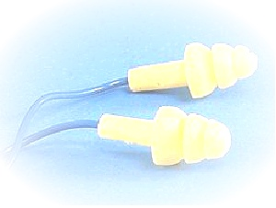
- Hard hats – when exposed to bumping into or struck-by hazards.
- Gloves & arm protection– when exposed to chemicals, heat, cold, radiation agents or abrasive surfaces.
- Respirators – when exposed to harmful inhalation hazards due to chemicals. Respirators have intended uses; ensure the respirator you are using is properly selected for the hazard to which you are exposed. For example, dust respirators are used for silica exposure when cutting block, organic cartridge respirators for trichloroethylene found in paints and resins.
- Safety harnesses with lanyards - when exposed to fall hazards.
- Eye and face protection – glasses are intended to be use to protect from impact hazards e.g. when using saws. Goggles protect the eyes from splash hazards. Face shields are intended to protect the face from splash hazards and should be worn with safety glasses or goggles.
- Welding hoods – when performing cutting, welding or brazing.
- Airline sand blasting hoods – used when sand- blasting. Ensure helper is protected also.
- Steel-toe shoes – for falling heavy objects
Hazard Communication
Purpose: Ensures hazards of chemicals are conveyed to employers and employees
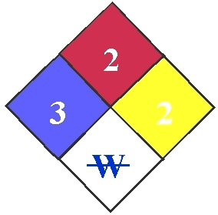
Chemicals on the Construction Site:
Flammable - Gasoline; diesel fuel; acetylene Accelerator - Oxygen Combustible - Curing compound Irritant – Mortar; curing compound; muriatic acid; asphalt; epoxy resin; lime; fiberglass; wood dust; formaldehyde Carcinogens - Welding metals (lead, nickel, chromates, beryllium); asbestos; formaldehyde Suspected Carcinogens - Epoxy resin; wood dust Lung Fibrosis - Silica Sensitizer - Isocynates
Identify Chemical Hazards: Look at product warning label and read MSDSs.
Written Program: Your employer should have developed a written program and made it available to you. The program must include: chemical inventory, MSDSs location, how and where employees will get information on new chemicals, who to ask questions on chemical safety and how to perform non-routine tasks safely.
Employee Training:
- Ensure each employee is trained in how to use hazardous chemicals safely and what safety equipment is required.
- Train employees to ensure they do not remove or deface labels on incoming containers of hazardous chemicals.
- Inform employees where MSDSs are maintained and how they should be used during emergency situations.
- Identify any operation on the jobsite where hazardous chemicals are present and post hazard warnings (physical and health), protective measures, equipment requirements or prohibited activity.
Industrial Trucks (Forklifts)
Hazards: Rollover injuries and struck-by injuries
Safe Practices:
- Only trained personnel are allowed to operate industrial trucks.
- Ensure substantial overhead protective equipment is provided on high lift rider equipment.
- Required lift truck operating rules should be posted and enforced.
- Ensure directional lighting (head lights) is provided on each industrial truck that operates in dark areas.
- Ensure each industrial truck has a warning horn, whistle, or other device, which can be clearly heard above the normal noise in the area.
- Ensure the brakes on each industrial truck are capable of bringing the vehicle to a complete and safe stop when fully loaded.
- Ensure the truck’s parking brake will prevent the vehicle from moving when unattended.
- Ensure that industrial trucks operating in hazardous areas (e.g. where flammable gases or vapors, combustible dust or ignitable fibers may be present) are approved for such locations.
- If industrial trucks with internal combustion engine operate in buildings or enclosed areas, carefully check to ensure such operations do not cause harmful concentration of dangerous gases or fumes.
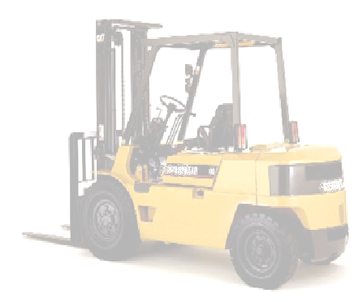
- Prohibit employees from riding on the lift truck unless a seat is provided.
- Use seat belts.
- Do not remove passenger compartment guards or rollover protection devices.
- Each rider must have a seat and not ride on sides or forks.
- Do not use people as counter weights or alter the truck in any way without the authorization of the manufacturer.
Fueling
Hazards: Fires, poisoning and burns
Safe Practices:
- Prohibit the fueling of an internal combustion engine with a flammable liquid while the engine is running.
- Keep spillage to a minimum.
- If spillage occurs during fueling operations, wash spilled fuel completely, evaporate, or take other measures to control vapors before restarting the engine.
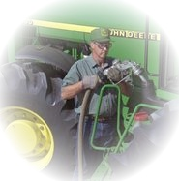
- Replace and secure cap before starting engine.
- Ensure metal contact between the container and the fuel tank.
- Ensure fueling hoses are of a type designed to handle the specific type of fuel.
- Do not handle or transfer gasoline in open containers.
- Prohibit open lights, open flames, sparking, or arcing equipment near fueling or transfer of fuel operations.
- Prohibit smoking in the vicinity of fueling operations.
- Prohibit fueling operations in buildings or other enclosed areas that are not specifically ventilated for this purpose.
- Ensure nozzles are self-closing when fueling or transferring fuel is done through a gravity flow system.

Confined Spaces
Hazards: Suffocation, poisoning, burns, entanglement and explosion
Confined or enclosed space may include: storage tanks, process vessels, bins, boilers, ventilation or exhaust ducts, sewers, underground utility vaults, tunnels, pipelines, and open top spaces more than 4 feet deep such as pits, tubs, vaults, and vessels.
Remember: You can actually build a confined space around yourself.
Safe Practices:
- Instruct all employees of the nature of the hazards involved, the necessary precautions to be taken, and in the use of required protective and emergency equipment.
- Ensure confined spaces are emptied of any corrosive or hazardous substances or vapors, such as acids or flammables, before entry.
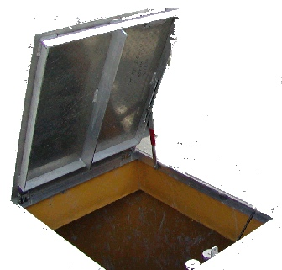
- Ensure all lines to the confined space that contain inert, toxic, flammable, or corrosive materials are valved off and blanked or disconnected and separated before entry.
- Ensure all impellers, agitators, or other moving parts inside confined spaces are locked-out if they present a hazard.
- Provide either natural or mechanical ventilation prior to confined space entry.
- Test the atmosphere for oxygen deficiency, explosive concentrations, and toxic substances before entry. Test atmosphere frequently or continuously during the work.
- Check the confined space for possible industrial waste that could contain toxic properties.
- Check space for animal matter or decaying vegetation that may produce methane.
- Provide approved respiratory equipment if the atmosphere inside the confined space cannot be made acceptable for breathing.
- Provide adequate illumination for the work to be performed in the confined space.

Confined Space
continued
- Assign a safety standby person outside of the confined space who will be responsible to watch the work in progress, sound an alarm if necessary, and render assistance.
- Ensure the standby employee is trained and equipped to handle an emergency.
- Prohibit the standby employee or other employees from entering the confined space without lifelines and respiratory equipment if there is any question as to the cause of an emergency.
- Ensure rescue equipment is available
- Provide means of communication for stand-by person to summon emergency help.
- Ensure all portable electrical equipment used is either grounded and insulated, or equipped with ground fault protection.
- Ensure hot work permits are provided for any hot work conducted in a confined space.
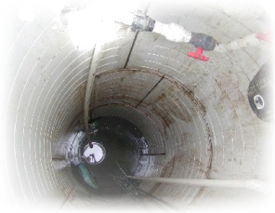
- Before gas welding or burning is started in a confined space, ensure hoses are checked for leaks, compressed gas bottles are forbidden inside of the space, torches are lighted outside of the space area and the confined area is tested for an explosive atmosphere each time before a lighted torch is taken into the confined space.
- Ensure employees, who will be using oxygen-consuming equipment, e.g. salamanders, torches, and furnaces in a confined space, is provided with sufficient air to assure combustion without reducing the oxygen concentration of the atmosphere below 19.5 percent by volume or create a toxic atmosphere.
- Whenever combustion-type equipment is used, make provisions to exhaust gases to outside of the enclosure. Check the confined space for vehicle exhaust or carbon monoxide if the space is below the ground and/or near areas where motor vehicles will be operating.
Flammable And Combustible Materials
Hazards: Fire, explosion and burns
Safe Practices:
- Ensure combustible debris, waste materials (oily rags, etc.) and waste solvents are stored in covered metal receptacles and removed from the worksite promptly.
- Provide approved containers and tanks for the storage and handling of flammable and combustible liquids.
- Use safety cans for dispensing flammable or combustible liquids at a point of use.
- Make connections on drums and piping tight.
- When not in use, ensure all flammable liquids are kept in closed containers.
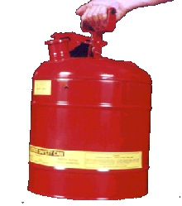
- Bond and ground drums of flammable liquids to containers during dispensing.
- Ensure storage rooms have explosion-proof lights and mechanical or gravity ventilation.
- Where flammables or combustibles are used or stored, post “NO SMOKING or OPEN FLAMES” signs physically guard liquefied petroleum storage tanks to prevent damage from vehicles.
- To assure support and stability, place firm separators between combustibles or flammables containers when stacked.
- Separate fuel gas cylinders and oxygen cylinders by distance and fire-resistant barriers while in storage.
- Do not block or obstruct fire extinguishers.
- Keep fire extinguishers serviced, maintained and tagged at intervals not to exceed 1 year.
- Clean up all spills promptly.
- Ensure storage tanks are adequately vented to prevent an excessive vacuum or pressure as a result of filling, emptying, or atmosphere temperature changes.
- Ensure tanks are equipped with emergency venting.
Material Handling
Hazards: Falling material and struck-by injuries
Safe Practices:
- Inspect motorized vehicles and mechanized equipment daily or prior to use.
- Shut off vehicles and set brakes prior to manually loading or unloading.
- Secure trucks and trailers from movement during loading and unloading operations.
- Prior to unloading, inspect load for shift, displacement or instability.
- Do not store material under energized electrical lines or in emergency exit ways.
- Keep hand trucks in safe operating condition.
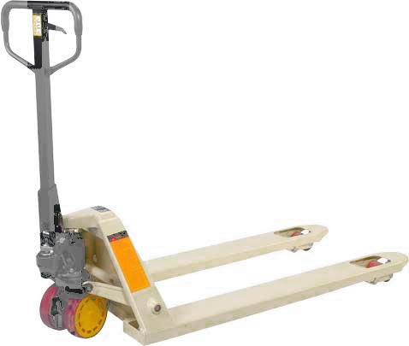
- Ensure safe clearance for equipment through aisles, doorways and roadways.
- Equip chutes with sideboards of sufficient height to prevent materials from free falling.
- Equip hooks with safety latches or other arrangements when hoisting materials so that slings or load attachments will not slip off the hoist hooks accidentally.
- Ensure securing chains, ropes, chokers or slings are adequate for the job.
- Assure no one will be passing under the suspended loads.
- Prohibit employees from riding on top of any load that can shift, topple, or otherwise become unstable.
- Ensure personnel do not ride in material hoist; post “No Riders Allowed” at hoist.
- Ensure entrances to hoistways are protected with caution gates or bars.
- Ensure persons who operate vehicles on public roads have valid operator’s licenses.
- Ensure cutting tools or tools with sharp edges are placed in closed boxes or containers which are secured in place when tools are carried in passenger compartments of employee transport vehicles.
- Ensure material safety data sheets are available to employees handling hazardous substances.
First Aid/BBP
Hazards: Delayed medical treatment
Prior to the work start:
    - Insure availability of medical personnel prior to the start of a project.
    - In absence of medial professional or facility that is reasonably located, ensure trained first aid providers are available.
    - Ensure first aid and CPR providers are certified by an accredited trainer.
    - Ensure first aid supplies are available in a weatherproof container and checked weekly for replacement of expended items.
    - Ensure transportation equipment is available.
    - Ensure emergency numbers are available and communication systems are working.
    - Provide an Automatic External Defibrillator (AED) at your work site and train first responder on its use
During an emergency:
    - Act promptly.
    - Assess injured workers’ situation and call for emergency help.
    - Use one-way protective device to perform mouth-to-mouth resuscitation.
    - Use pressure to stop bleeding; ensure you use gloves to protect from blood exposure.
    - Use tourniquet only if absolutely necessary.
    - Prevent shock by wrapping victim in blankets.
    - Do not move a person with a back or neck injury unless a greater hazard exists (e.g. fire.) Move on backboard.
    - Splint broken bones and joints.
    - Do not give liquids to an unconscious victim.
    - Clean and bandage surface wounds with sterile bandages.
    - Treat 1st and 2nd degree burns with clean cold water and apply sterile bandage to prevent infection; do not break blisters or use ointments. If 2nd degree burns cover a large area of skin, seek medical treatment. 3rd degree burns are medical emergencies. Call 911. If the person’s clothes are on fire, extinguish flame by smothering flames.
Housekeeping
Hazards: Slips, trips, falls and fires
Safe Practices:
- Keep trash and loose materials picked up and disposed of properly.
- Remove tripping hazards.
- Keep lines of traffic open.
- Do not place objects in ways of exits.
- Keep floors, ladder rungs and stairways dry and free from oil and grease.
- Ensure pile or stock is stable.
- Put tools and equipment in areas where they belong.
- Do not store loose materials on scaffolds.
- Do not store more than one shift of material (e.g. block or brick) on scaffolds.
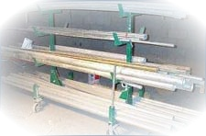
- Store material for stable removal.
- Leave space for workers and equipment to load and unload stored materials.
- Ensure the platform, scaffold or support has adequate strength for the weight of material.
- Keep the height of stored material low for stability and line of sight.
- Store pipe and rods in building racks.
- Clear scrap lumber with protruding nails from work areas, passageways, and stairs, in and around buildings or other structures.
- Remove combustible scrap and debris regularly.
- Provide containers for the collection of waste, trash, oily and used rags, and other refuse.
- Ensure containers for oily, flammable, or hazardous wastes, such as caustics, acids, etc. are equipped with covers.

- Do not drop material outside the exterior walls of the building or structure.
- Enclose material chutes.
- Guard openings and discharge of material chutes.
- Ensure the site has good lighting. Replace lights immediately when they burn out.
- Remember if waste is allowed to accumulate for just a few days, the job becomes messy and unsafe.

- Concrete and Masonry
Hazards: Struck-by injuries (also see Silica)
Safe Practices:
    - Do not place construction loads on a concrete structure or portion of structure unless it has been determined, based on information received from a person who is qualified in structural design, that the structure is capable of supporting the loads.
    - Prohibit employees from working under concrete buckets.
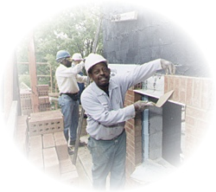
    - Route elevated concrete buckets so no employee is exposed to struck-by hazards.
    - Design, fabricate, erect, support, brace and maintain formwork so it can support all anticipated vertical and lateral loads.
    - Do not remove forms and shoring until it has been determined through stipulated conditions or an appropriate ASTM method that the concrete has gained sufficient strength to support its weight and superimposed loads.
Limited Access Zone (LAZ):
    - Establish LAZ whenever a masonry wall is being constructed.
    - Ensure LAZ is established prior to the start of construction of the wall.
    - Ensure LAZ is equal to the height of the wall to be constructed plus 4 feet and runs the entire length of the wall.
    - Ensure the LAZ is established on the side of the wall that will not be scaffolded.
    - Allow entry to only the employees actively engaged in constructing the wall.
    - Ensure the LAZ remains in place until the wall is adequately supported to prevent overturning and collapse.
    - Ensure all masonry walls more than 8 feet in height are adequately braced to prevent overturning and collapse unless the wall is adequately supported so that it will not overturn or collapse. Keep bracing in place until permanent supporting elements of the structure are in place.

Road Work Safety

What is a Work Zone?
- Temporary traffic control zone, change from normal traffic patterns, where people & equipment are at risk.

Operations in a Work Zone:
- Construction, maintenance, utility work, emergency response, environmental sampling.

Regulations to Follow:
- All traffic control operations and devices must conform to Manual on Uniform Traffic Control Devices (MUTCD) and State DOT Design Standards. MUTCD Available on line from DOT -- http://mutcd.fhwa.dot.gov

Traffic Control Devices:
- Traffic control devices include signs, channelizing devices, lighting devices and pavement markings.
- Signs: Regulatory signs impose legal restrictions and may not be used without permission. Guide signs typically show destinations and directions. Warning signs give notice of conditions that may be hazardous. Used extensively in road construction, signs must be retroreflective or illuminated during hours of darkness, meet minimum size requirements, meet mounting standards and removed when work is over.
- Channelizing Devices include: traffic cones, tubular marker, vertical panel, drums, barricades and barriers.
- Traffic cones most common, must be orange in color, minimum heights for certain jobs and retroreflective if used in darkness.

Lighting Devices include: warning lights, flashing vehicle lights and arrow displays

Mobile Operations:

Ensure warning devices are used for mobile operations at speeds above 20 mph.
- Use portable devices that are appropriately colored.

Continued on next page

Road Work Safety
continued
Mobile Operations
- Use marked vehicles with flashing or rotating lights.
- Augment portable devices with signage.
- Use advance-warning devices that move with the work area.

Safe Practices:
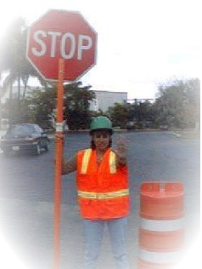
    - Use protective measures, such as, high-visibility clothing, traffic control devices, work-zone protection plan, law-enforcement and public awareness, worker training, variable message signs (VMS), arrowboards, crash cushions, impact attenuators and jersey barriers.
- Ensure the traffic control zone is divided and maintained in five distinct areas – advance warning area, transition area, buffer area, worker area and termination area
- Ensure employees work inside the”work area” of the traffic control zone.
- Ensure retroreflective and illuminated devices are used at intermediate and long-term stationary temporary traffic control zones
- Use properly spaced advance warning signs for lane tapering and certain shoulder work
- Use traffic control devices with traffic barriers that are immediately adjacent to an open lane
- Use temporary traffic barriers separating opposing traffic on a two-way roadway
- Ensure Flaggers have certified training (NSC, ATSSA or equivalent.)

Inside the Work Zone:
- Ensure vehicle backup alarms are used
- Ensure alarms are loud enough to be heard over the noise being emitted by work
- Ensure trucks are equipped with mirrors.
Equip construction vehicles with proximity detectorsImplement an Internal Traffic Control Plan that includes: schematics of vehicle and worker movements, hazard checklist, reporting system, adequate lighting, and plans for intermittent stoppages

Vehicle Safety
Hazards: Struck-by and roll-over injuries
Safety Equipment: Seat belts, rollover protective structure, brakes, horn, reverse alarm
Inspection: Inspect vehicles before each shift to assure that all parts and accessories are in safe operating condition. Check brakes, trailer brake connections, parking system, emergency brakes, tires, coupling devices, seat belts, horn, steering mechanism, operating controls, safety devices (e.g. reverse signal alarm, ROPS), lights, reflectors, defrosters, windshield wipers and fire extinguishers.
Safe Practices:
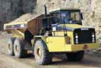
- Do not drive a vehicle in reverse gear with an obstructed rear view, unless the vehicle is equipped with an audible reverse alarm or another worker signals that it is safe.
- Drive on roadways or grades that are safely constructed and maintained.
- Make sure you and all personnel are in the clear before using dumping or lifting devices.
- While not in use, lower or block bulldozer and scraper blades, end-loader buckets, dump bodies, etc., and leave all controls in neutral position.
- Set parking brakes when vehicles and equipment are parked, and chock the wheels
- Haulage vehicles that are loaded by cranes, power shovels, loaders etc., must have a cab shield or canopy that protects the driver from falling materials.
- Do not exceed a vehicle's rated load or lift capacity.
- Do not carry personnel unless there is a seat available; no one should ride in buckets or on forks.
- Use traffic signs, barricades or flaggers when construction takes place near public roadways.
- Workers should wear highly visible warning clothing, such as red or orange vests, and reflective vests.
- Wear provided seat belts.
Workplace Violence
Workplace violence is predictable: It doesn’t just happen; it develops like a storm; workers see and hear things which they should report.
Workplace violence includes: beatings, rapes, stabbings, suicides, shootings, psychological trauma, threatening phone calls, intimidation, harassment, stalking and verbal abuse.
Sources of violence include: strangers, clients, co-workers and personal relations.

Risk Factors include: contact with the public, working with unstable or volatile persons, delivery of passengers or goods, working alone or in small numbers, working late at night or during early morning hours, working in high-crime areas, guarding valuable property and money exchange.
Be Alert to Warning Signs: Fascination with weapons, alcohol or drug abuse, anguish over pending or recent demotion or termination, history of violent incidents, severe stress, social isolation, psychological deterioration, decreased or inconsistent job functioning, deterioration in personal hygiene and major personality changes.
Safe Practices:
- Management has zero tolerance for violence, threats, harassment, intimidations, and other disruptive behavior in the workplace.
- Reports of incidents will be taken seriously; line supervisors are accountable to act upon reports of violence.
- Workers will report violent behavior to ____.
- No one will receive reprisals for reporting.
- Management is committed to emotional and physical health of the employee.
- The employer has implemented security measures which include: locks on doors, cell phones and walkie-talkies, adequate lighting, lockers for valuables, night-time guards, identity badges, surveillance cameras, curved mirrors and controlled access to work areas.
- Call 911 - for any physical actions or threats which appear imminent, acts of physical harm or property damage or out-of-control behavior
Lead in Construction
Lead: This chemical is most commonly inhaled into the body by as a dust, fume, or mist. Lead can also be absorbed through the digestive system when it enters the mouth and is ingested.
Hazards: Lead is a toxic metal with chronic overexposure symptoms including: nausea, loss of appetite, constipation, fatigue, headache, fine tremors, and metallic taste in the mouth, colic with severe abdominal pain, nervous irritability, weakness and hyperactivity. Lead is toxic to both male and female reproductive systems and children born to parents who were exposed to excess lead levels are more likely to have birth defects, mental retardation or behavioral disorders.

Workers at the highest risk: Those involved in abrasive blasting and welding, cutting, and burning on steel structures. Other operations with potential exposure include: lead burning, using lead-containing mortar, powered tool cleaning without dust collection systems, manual dry scraping and sanding, cleanup activities, removal of abrasive blasting enclosures, demolition of structures, heat-gun applications, and spray painting with lead-based paint.
Safe Practices:
- Eliminate lead from operations.
- Conduct an exposure assessment to ensure workers’ airborne lead levels are below the Permissible Exposure Limit (PEL) of 50ug/m³ of air for an 8-hr work-shift.
- For airborne levels that are above the Action Level (AL) of 30ug/m³, air monitoring will be conducted at regular intervals and the affected employees will be placed in a medical surveillance program and/or in a medical removal program.
Controls:
  - Implement engineering and work practice controls that include: HEPA filtered exhaust ventilation, isolation techniques, material substitution, good housekeeping and warning signage and posting.
  - Institute respiratory protection program.
  - Inform of medical and air monitoring results.
Back Injuries
Hazards: Back, neck and shoulder pain, sprains and strains, pinched nerves and slipped discs
Background: Most injuries occur from lifting, lowering, carrying, pushing, and pulling materials. You are at higher risk of low-back injury if you often carry heavy loads, must twist while carrying heavy loads, or work a lot while bent over or in other awkward postures.
Safe Practices:
  - Perform warm-up exercises before work.
  - Reduce carrying distances by delivering materials close to where they will be used.
  - Try to store materials at waist height.
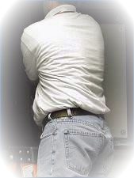
  - Raise your work surface to waist level, e.g. pipefitters can use pipe stands, masons can use adjustable scaffolds.
  - Ensure floors and walking surfaces are clear and dry.
  - Take rest breaks before getting too tired.
  - Use carts, dollies, forklifts, and hoists to move materials.
  - Use carrying tools with handles to get a good grip on wallboard or odd-shaped loads.
  - When lifting or carrying materials, keep the load as close to your body as you can.
  - Try not to twist when lifting and lowering materials. Turn your whole body instead.
  - Lift and lower materials in a smooth steady way. Try not to jerk the lift.
  - Try supporting yourself by leaning on something while performing a low lift.
  - Don't bend over; instead, kneel on one knee and pull the load up onto your knee before standing. (Wear kneepads when you kneel.)
  - Ensure young apprentices are protected against back injuries, so they will not receive back injuries and have to leave the trade.
  - Work with your employer to decide how the work can be changed to protect you and your co-workers from back injuries.
  - Injuries can be reduced by planning, changing how work is performed and training workers and supervisors.
Asbestos
Asbestos: Asbestos fibers are very small. If you inhale them, they go deep into your lungs and cause disease up to 40 years later.
Hazards: Exposure to asbestos has been shown to cause lung cancer, mesothelioma, and cancer of the stomach and colon. Smoking increases the health risk.
How does asbestos exposure occur?
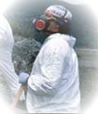
- Asbestos products can release fibers into the air when they are friable, abraded cut or disturbed. Asbestos products are called friable when you can crush them with finger and hand pressure alone. Exposure is most likely when renovating or demolishing older structures.
Common Sources:
Asbestos may be in roofing felt, roof patch material, vinyl tile, linoleum backing, "transite”, asbestos cement pipe and sheet, pipe insulation, fireproofing, and spray-on decorative acoustical ceiling material. Most new products don’t contain asbestos (but foreign materials may contain it).
Safe Practices:
  - Assign a competent person to administer the company’s exposure control plan.
  - Send suspected materials for testing.
  - Conduct daily or periodic air monitoring depending on the class of work performed.
  - Properly trained crews who will work with asbestos.
  - Have workers get regular medical exams.
Controls:
  - Restrict access to the asbestos area.
  - Post warning signs.
  - Use HEPA filtered respirators (not just dust masks) and full body coverings.
  - Wet down the asbestos to reduce dust.
  - Use power tools with special exhaust filters.
  - Material containing asbestos, e.g., waste, scrap, and contaminated clothing that is removed from buildings must be disposed of in leak-tight 6-mil thick plastic bags, plastic-lined cardboard containers, or plastic-lined metal containers.
Lightning
Hazards: Electrical shock and death
If a storm is near:
  - Stop all outdoor operations until storm has long passed
  - Do not be the tallest object in an area
  - Do not stand out in the open.
  - Do not stand under a tree (If the tree is hit, you can be too.)
  - Do not stand in a gazebo or open shelter
  - Do not stand next to metal objects – pipes or light poles or door frames or metal fences or communication towers – indoors or out
  - Do not stay next to water – ponds or running water – indoors or out. (Don’t take a shower)

  - Do not use plug-in power tools or machines – indoors or out
  - Do not use a plug-in telephone (or a computer with a modem) – indoors or out
  - Get into an enclosed building
  - Get into a car, van, truck, or bus with the windows closed all the way. Do not touch the doors or other metal inside
  - Open cabs on heavy equipment will not protect you
  - Rubber tires will not protect you
If someone is hit by lightning:
  - Call 911 emergency services
  - A victim does not stay electrified and you can touch him/her right away. If the victim has no pulse, try cardiopulmonary resuscitation.
  - If there’s a portable defibrillator, follow the instructions.
  - Transport the victim to a safe area or you may be struck by lightning too.
  - Move the victim to a shelter if possible.
Be prepared:
- Know policies and plans for inclement weather
- Be prepared for securing premises for hurricanes and other pre-warned storms
- Have safe meeting places for tornadoes

Silica
What is crystalline silica? Crystalline silica is a basic component of soil, sand, granite, and many other minerals. Quartz is the most common form of crystalline silica. The dust may become respirable size particles when workers chip, cut, drill, or grind objects that contain crystalline silica.
Hazards: Crystalline silica has been classified as a human lung carcinogen. Breathing crystalline silica dust can cause silicosis, which can cause severe shortness of breath, weakness, and weight loss, fatigue, chest pain, and in severe cases can be disabling, or even fatal. Smoking adds to the damage caused by silica dust.
Controls:
- Replace crystalline silica materials with safer substitutes
- Use engineering controls, such as, local exhaust ventilation and blasting cabinets
- Use protective equipment or other protective measures to reduce exposures below PEL
- Use work practices controls, such as water sprays when cutting bricks and blocks
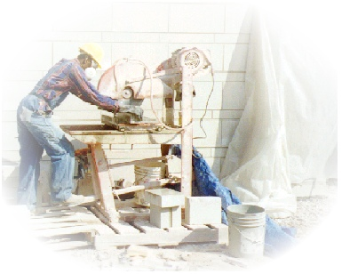
- Wear only N95 NIOSH certified respirators, if respiratory protection is required
- Do not alter the respirator.
- Respirators can not be worn by workers with facial hair, such as beards. It prevents a good seal between the respirator and the face.
- Wear only a Type CE abrasive-blast supplied-air respirator for abrasive blasting
- Shower if facilities are available and vacuum the dust from your clothes or change into clean clothing before leaving the work site
- Participate in training, exposure monitoring, and health screening and surveillance programs to monitor any adverse health effects caused by crystalline silica exposures
- Do not eat, drink, smoke, or apply cosmetics in areas where crystalline silica dust is present
Remember: If it’s silica, it’s not just dust.

Hand and Portable Tools
Hazards: Lacerations, fractures, amputations, electrical shock and electrocutions
Inspections: Ensure all tools and equipment (both company and employee owned) are in good condition.
- Replace hand tools such as chisels and punches, which develop mushroomed heads
- Replace hammers, axes and similar tools that have broken or fractured handles
- Ensure tool handles are wedged tightly in the head of all tools
- Ensure tool’s cutting edges are kept sharp
- Ensure grinders, saws and similar equipment is provided with appropriate safety guards
- Ensure power tools are used with the correct shield, guard or attachment
- Ensure all cord-connected, electrically operated equipment are effectively grounded or of the approved double insulated type
- Ensure effective guards are over belts, pulleys, chains, sprockets, pinch points and points of operation
- Ensure ground-fault circuit interrupters are provided on all temporary electrical 15 and 20 ampere circuits
- Check pneumatic and hydraulic hoses on power-operated tools for deterioration
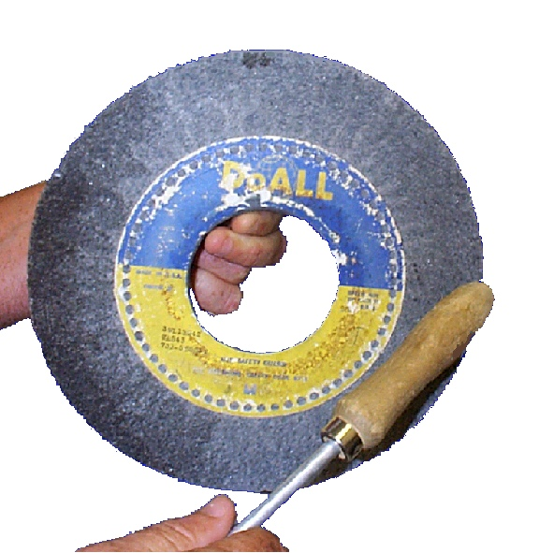
- Ensure the work rest is adjusted to within 1/ 8 inch to the wheel and the tongue is adjusted to within 1/4 inch to the wheel on abrasive wheel grinders
- Ensure side guards cover the spindle, nut, and flange and 75 percent of the wheel diameter on abrasive wheel grinders
- Ensure the maximum RPM rating of each abrasive wheel is compatible with the RPM rating of the grinder motor
- Ensure new abrasive wheels are visually inspected and ring-tested before use
- Ensure appropriate safety glasses, face shields, etc. are used while using hand or powered tools or equipment which might produce flying materials or is subject to breakage
Welding, Cutting And Brazing
Hazards: Burns, shock, electrocution and poisoning.
Safe Practices:
- Only authorized and trained personnel are permitted to use equipment
- Use shielding to protect other persons in the vicinity from effects of direct arc rays
- Remove electrode and protect holder from accidental electrical contact when equipment is left unattended
- Ensure electric power to the welder is off when no one is in attendance
- Inspect and ensure cables are completely insulated and capable of handling the maximum current required for the job
- Fuel gas and oxygen hose shall be easily distinguishable and not interchangeable
- Inspect and replace or repair defective hoses at the beginning of each shift
- Use proper eye protective equipment
- Ensure grounding of the machine frame
- Inspect and ensure safety ground connections of portable machines
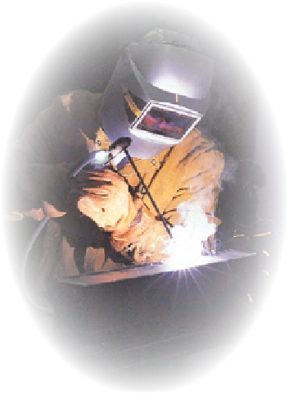
- Do not allow the worker to coil or loop welding electrode cable around his body
- Ensure suitable fire extinguishing equipment is available for immediate use
- Assign firewatchers when welding or cutting in locations where fire might develop
- Keep welding hoses clear of any falling metal, slag or sparks
- Keep combustible floors wet, covered by damp sand, or protected by fire-resistant shields
- When floors are wet down, ensure personnel are protected from possible electrical shock
- Dry and test wet machines before use
- While working in confined spaces or in any place where an unusual condition can cause an unsafe accumulation of contaminants, general mechanical ventilation, local exhaust ventilation, air-line respirators, and other protective devices should be provided.
Compressed Gases
Hazards: Burns and poisoning
Storage: Mark empty cylinders and close valves. Always keep gas cylinders secured properly and in a vertical position. Keep valve protection caps in place whenever cylinders are not in use.
Safe Practices:
- Do not use cylinders as rollers or supports
- Keep all cylinders, cylinder valves, couplings, regulators, hoses and apparatuses free of oily or greasy substances
- Unless secured on special trucks, regulators are removed and valve-protection caps put in place before moving cylinders
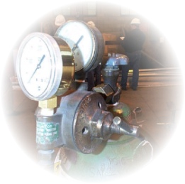
- Never crack a fuel gas cylinder valve near sources of ignition
- Close valve and release gas from the regulator before a regulator is removed
- Examine compressed gas cylinders regularly for signs of defects, deep rusting, or leakage
- Only use pressure-reducing regulators for the gas and pressures for which they are intended
- Open cylinder valves slowly and carefully
- When a cylinder wrench is needed on the valve, keep the wrench near-by to turn off the valve quickly if necessary
- Use red to identify the acetylene (and other fuel-gas) hose, green for oxygen hose, and black for inert gas and air hose
- Only qualified technicians should clean or repair a regulator
- Do not tamper with the relief valve or remove it from a regulator
- Read MSDSs and train about fuel gases
- Never allow oxygen to contact oil, grease or other flammable substances
- Never use oxygen as a substitute for compressed air
- Never use oxygen to dust off clothing, in pneumatic tools, or for ventilation

Electrical
Hazards: Burns, shock and electrocutions
Inspections:
- Ensure all tools and equipment (both company and employee owned) are in good condition
- Prohibit work on energized electrical circuits
- Prohibit the use of frayed or worn electrical cords or cables
- Ensure that only grounded type extension cords designed for hard or junior hard service (Type SJ, SJO, SJT, SJTO, S, SO, ST, and STO) are used
- Check portable electric tools before use to ensure that the cord and plug are in good condition
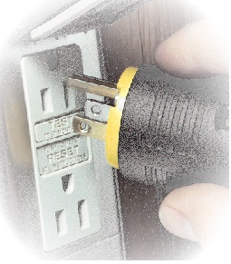
- Ensure that broken or damaged tools and equipment are removed from service
- Ensure that portable electrical tools and equipment are either grounded or of the double insulated type.
- Ensure that each 15 or 20 ampere, 120 volt AC receptacle, not part of the permanent wiring of the building, are protected by either ground-fault circuit interrupters or an Assured Equipment Grounding Program
- Ensure that electrical equipment and cords used in wet or damp locations are approved for wet and damp locations. Ensure that listed, labeled, or certified equipment is used in accordance with the instructions included in the listing, labeling, or certification.
- Ensure that when a circuit breaker is removed from a circuit breaker panel, it is replaced with either a breaker or a blank
- Ensure that unused openings in electrical boxes are effectively closed
- Prohibit bypassing any protective system or device designed to protect employees from contact with electrical current
- Ensure that electrical cords are protected from physical damage
- Ensure electrical equipment is used only as approved and listed

Lockout / Tagout
Hazards: Amputations, fractures, electrocution and death
What is Lockout / Tagout (LOTO): A way to make sure electricity or other energy is not turned on (or released) while someone is working on machinery. Turning off a power switch is not enough. You must de-energize (prevent equipment from starting or moving), lock it out, release stored energy (for instance, bleed air from a pneumatic hose), and test to make sure the energy is off.
Lockout / Tagout Procedures:
  - Each piece of equipment or machinery should have its own LOTO procedures
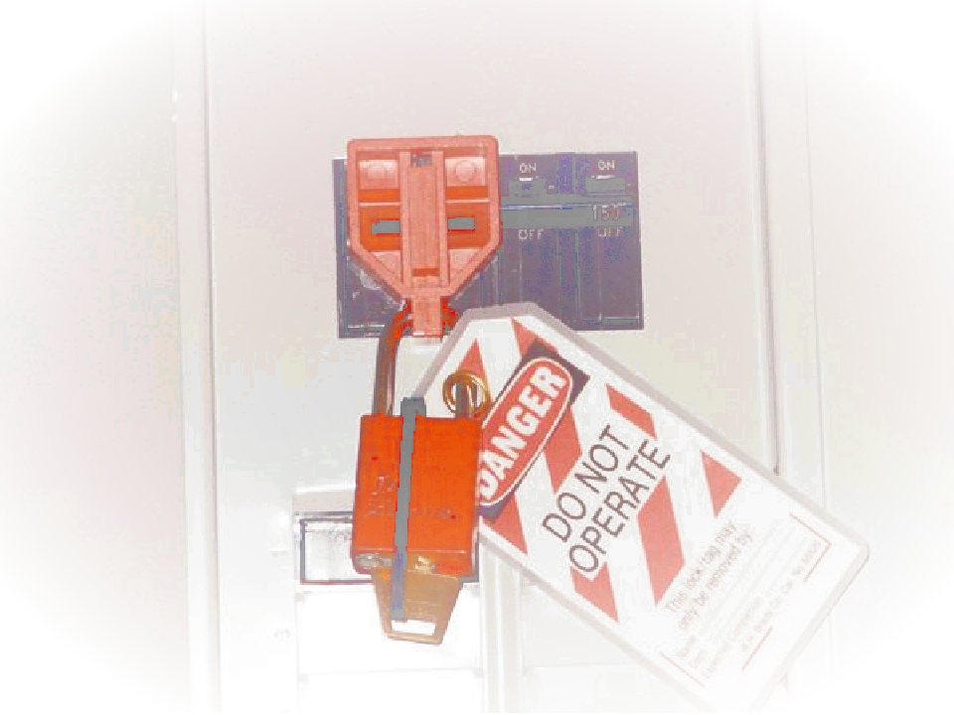
  - Notify operators and supervisors that power is being disconnected or isolated
  - Prepare for isolation by checking for specific written procedures that state the shutdown and restart process
  - Shutdown by turning off the equipment
  - Separate all energy sources using proper isolating devices – like manual circuit breakers or disconnect switches
  - Pushbuttons or selector switches cannot be the only way to de-energize. Equipment may have more than one type of energy that needs to be isolated
  - Each worker who can be exposed to hazardous energy must be part of the LOTO process
  - Control stored energy, e.g. discharge capacitors or drain hydraulic lines
  - Verify equipment has been de-energized by trying to restart and using testing equipment (such as an electric circuit tester)
  - Only the worker who puts on a lockout or tagout device may remove it
  - When the work is finished, inspect to ensure all tools, mechanical restraints, and electrical devices have been removed before you turn on power. Warn affected employees that power will be restored.
  - If the LOTO job is interrupted for testing or positioning equipment, the procedures must start over from the beginning
Stairways
Hazards: Falls, fractures, strains and sprains
Safe practices:
- Stairways or ladders are provided at worker points of access where there is a break in elevation of 19 inches
- Ensure stairrails are installed on all stairways with 4 or more risers, or rising more than 30 inches
- Ensure that stairrails are not less than 36 inches in height
- Ensure guardrails are installed on all stairs prior to use
- Ensure that stairways are not being used to store materials
- Except during construction of the actual stairway, skeleton metal frame structures and steps must not be used, unless the stairs are filled and secured with temporary treads and landings.
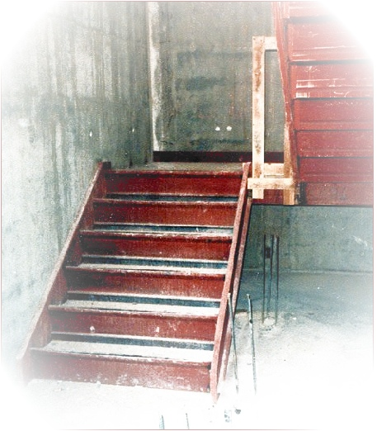
- Ensure that midrail screens, mesh, intermediate vertical members or equivalent intermediate structural members are provided between the top rail and the stairrail system.
- Ensure that temporary handrails have a minimum clearance of 3 inches between the handrail and the walls, stairrail system, and other objects.
- Ensure that the unprotected sides and edges of stairway landings are protected by a standard guardrail system.
- Ensure that stairways are installed at least 30 degrees, and no more than 50 degrees from the horizontal.
- Ensure that a platform is provided at all locations where doors or gates open directly onto a stairway.
- Ensure that the swing of gates and doors do not reduce the effective width of the platform to less than 20 inches.
Cranes and Rigging
Hazards: Fractures, lacerations and death
Inspections:
- Never use a crane unless specifically trained as a crane operator
- Never use a crane that is not in perfect mechanical condition
- Ensure operator inspects and tests crane prior to each shift
- Check limit switches before rigging load.
- Inspect all rigging before use
Safe Practices:
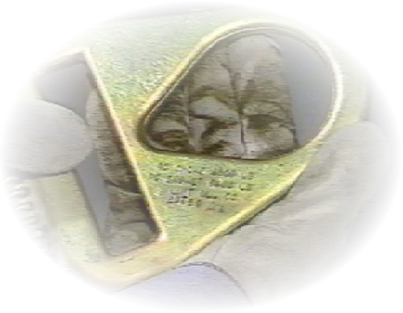
- Know the rated capacities of the crane and rigging
- Know the center of gravity of the load
- For stability, attach load above the center of gravity
- Select hitch that will control the load
- Allow for load reductions when using choker hitches
- Attach tag line prior to lift
- Protect the sling from sharp corners
- Allow for increased tension due to sling angle
- Equalize loading on multiple leg slings
- Lift load a few inches and verify rigging
- Check for any loose items
- Start and stop SLOWLY! Watch for obstructions (not only hook and load but outboard end of the bridge).
- Ensure pathway is clear before making a lift (use a spotter for blind spots)
- Verify hook completely closes
- Wear hard hats when making overhead lifts
- Avoid working under loads
- Keep personnel clear of lift area
- Use appropriate hand signals
- Maintain load control at all times
- Report suspected drum wrappings immediately (if drum has fewer than 2.5 wraps remaining)
- Never leave load unattended
- Destroy defective sling and rigging before throwing away
- Stay clear of overhead power lines (10ft min.)
- Stop operation during high wind
- Fire Prevention
Hazards: Burns and smoke inhalation
- Safe practices:
- Ensure that fire extinguishers are provided near all welding, soldering, and other sources of ignition.
- Ensure that fire extinguishers are available and readily accessible in case of an emergency.
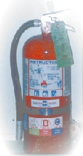
- Ensure that portable fire extinguishers are periodically inspected and maintained in accordance with Maintenance and Use of Portable Fire Extinguishers, NFPA No. 10A-1970.
- Ensure that at least one 2A rated fire extinguisher is provided for each 3000 square feet of the protected building area.
- Ensure that employees do not have to travel more than 100 feet to reach the nearest fire extinguisher.
- Ensure that flammable and combustible materials are not stored in stairways or exits.
- Ensure that adequate ventilation is provided in areas where paints, solvents or other flammable materials are being applied. The build-up of fumes and vapors can lead to fires or explosions.
- Ensure that gasoline and other flammable liquids are stored in safety cans or in an approved flammable storage facility.
- Ensure that flammable liquid leaks or spills are cleaned up immediately.
- Prohibit smoking in the vicinity of operations that constitute a fire hazard, and conspicuously post “No Smoking or Open Flames” signs.
- Prohibit the use of solid fuel salamanders in buildings and on scaffolding.
- Ensure that heaters are set horizontally level, unless otherwise permitted by the manufacturer’s instructions.
- Ensure that an alarm system is established, so that employees and the local fire department can be alerted for an emergency.
Overhead Power Lines
Hazards: Electrical shock and electrocution
Safe practices:
- Always survey the site for overhead power lines - LOOK UP!
- Always locate and identify overhead electrical power lines
- Remember when using crane or high reaching equipment near energized power lines of 50,000 volts (50 Kv) or more, the minimum distance between the lines and any part of the crane / equipment must be 10 feet plus ½ inch for each 1000 volts over 50,000 volts.
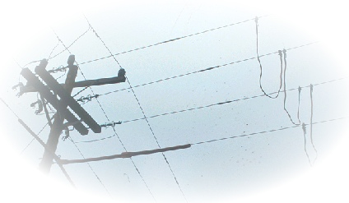
- Always request an observer when you do not have a clear view of power line from your operating station
- The observer’s only job should be ensuring that the operator maintains a safe distance from overhead power lines
- Always treat overhead power lines as if they are energized
- When in doubt, contact the electric company to determine what voltage is on the lines
- Always ask the electric company to either de-energize and ground the lines or install insulation while you are working near the lines
- Even with insulation, a minimum safe clearance must be maintained from the from the power lines
- Always make sure ladders and tools used near power lines are nonconductive

Trenching
Hazards: Fractures and suffocation
Safe practices:
- Ensure that the competent person received specific training in, and is knowledgeable about soil analysis, use of protective systems, and the requirements of 29 CFR 1926-Subpart P: Excavations and Trenches.
- Ensure that the competent person has classified the soil using one manual and one visual test.
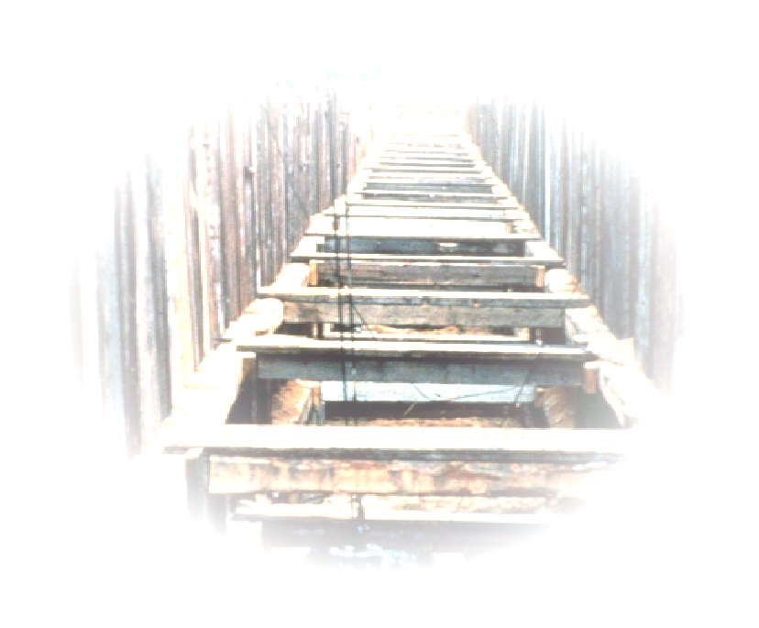
- Ensure that excavations, adjacent areas, and protective systems are inspected by a competent person prior to the start of work, as needed throughout the shift, and after rainstorms or other occurrences that could increase the hazard.
- Ensure that spoils, materials, and equipment are set back a minimum of 2 feet from the edge of the excavation.
- Prohibit employees from walking or working under suspended loads.
- Ensure that utilities companies are contacted and/or underground utilities are located as required by local, state, and federal law.
- Ensure that workers inside an excavation are within 25 feet of a means of access/egress.
- Ensure that ladders used in excavations are secured and extend at least 3 feet above the edge of the excavation.
- Ensure that employees are protected from cave-ins when entering or exiting from an excavation.
- Ensure that precautions are taken to protect employees from water accumulation.
- Ensure that the atmosphere inside the excavation is tested when there is reasonable possibility of an oxygen-deficient, oxygen-enriched, combustible or toxic atmosphere or any other harmful contaminants.
- Ensure employees are trained to use personal protective equipment and other rescue equipment.
- Ensure that materials and equipment used for protective systems are inspected and in good condition.
Scaffolding
Hazards: Falls, fractures and death
Safe practices:
- Construct scaffolds according to the manufacturer’s instructions
- Use screw jacks, base plates and mudsills to ensure adequate support
- Install a guardrail system or fall arrest system for scaffolds more than 10 feet above a lower level
- Ensure that guardrails are installed on all open sides and the ends of platforms
- Provide safe access to scaffold platform
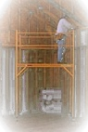
- Prohibit employees from climbing the cross bracing as a means of access
- Prohibit the use of unstable objects to support scaffolds
- Front-end loaders, forklifts, etc., are not to be used for support unless designed for use
- Ensure that platforms do not deflect more than 1/60 of span when loaded
- Prohibit moving a scaffold while employees are on the scaffold
- Prohibit working from scaffold during storms or high winds unless the competent person okays work and wind screens or fall arrest systems are used. A windscreen may only be used when the scaffold is secured against anticipated wind forces
- Ensure that scaffolds are inspected before each shift by a competent person, who is capable of identifying scaffold hazards and who has the authority to correct the hazards
- Ensure employees working on scaffolds are trained by a person qualified to recognize hazards associated with the type of scaffold and to understand the procedures to control or minimize hazards
- Employees erecting, dismantling, moving or inspecting the scaffolds must be trained by a competent person to recognize any hazards
- Require employees to be retrained when employees demonstrate a lack of skill or understanding in the scaffolding requirements
Fall Protection
Hazards: Falls, fractures and death
Safe Practice:
- Ensure that the jobsite is assessed to determine if the walking and working surfaces have the strength and structural integrity to safely support workers
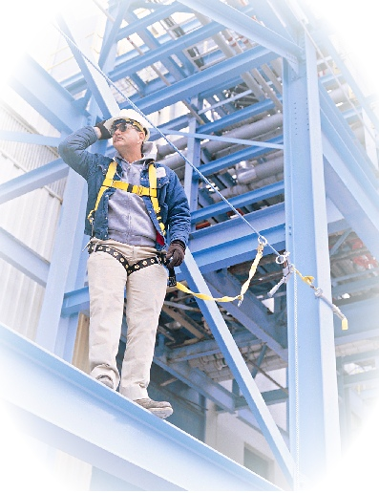
- Ensure that workers exposed to falling 6 feet or more from an unprotected side or edge, are protected by a guardrails system, safety net system, or personal fall arrest system
- A personal fall arrest system consists of an anchorage, connectors, body harness, and may include a lanyard, deceleration device, lifeline, or a suitable combination
- Ensure that workers in a hoist area exposed to 6 feet or more fall are protected by either a guardrails system or personal fall arrest system
- Ensure that employees exposed to a floor hole more than 6 feet above lower levels are protected by personal fall arrest systems, covers, or guardrail systems
- Ensure that employees using ramps, runways, and other walkways are protected from falling 6 feet or more by a guardrail system
- Ensure that employees engaged in roofing activities on low-slope roofs with unprotected sides and edges 6 feet or more above the lower level are protected from falling by a guardrail system, safety net, personal fall arrest system, or a combination warning line system and guardrail system, warning line system and safety net system, warning line system and personal fall arrest system, or warning line system and safety monitoring system
- Ensure that employees engaged in roofing activities on steep roofs with unprotected sides and edges 6 feet or more above the lower level are protected from falling by a guardrail system with toeboards, safety net, personal fall arrest system

Aerial Lifts
Hazards: Falls, broken bones and death
Aerial lifts: Vehicle-mounted aerial devices used to elevate personnel to job-sites above ground. Examples include: extensible boom platforms, aerial ladders, articulating boom platforms, vertical towers and a combination of any such devices. Aerial equipment may be powered or manually operated and may or may not be capable of rotating about a vertical axis.
Safe Practices:
  - Test lift controls each day prior to use
  - Only authorized persons can operate the lift
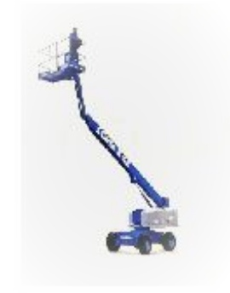
  - Do not tie-off to an adjacent pole, structure, or equipment while working from an aerial lift
  - Stand firmly on the floor; do not sit or climb on the edge of the basket or use planks, ladders, or other items for a work position.
  - Wear a body harness (or restraining belt) and lanyard attached to the boom or basket
  - Do not exceed specified load limits
  - Set the brakes during use
  - Position outriggers on pads or solid surface.
  - Use wheel chocks when on an incline
  - Do not move when boom is elevated in a working position with men in the basket, except for equipment that is specifically designed for this type of operation
  - Ensure boom platforms, primarily designed as personnel carriers have both platform (upper) and lower controls
  - Ensure upper controls are within easy reach of the operator
  - Lower controls should override upper controls but should only be used if permission is given by the worker in the lift or during an emergency
  - Ensure controls’ functions are denoted
  - Field modifications may only be made with the manufacturer’s written approval
  - Ensure aerial ladders are secured in the lower traveling position by the locking device on top of the truck cab and the manually operated device at the base of the ladder before the truck is moved for highway travel
  - Use caution when working near overhead power lines; maintain lift, equipment and personnel 10 feet from overhead power lines
Construction Resource
For more information on hazards and OSHA standard, view www.osha.gov and refer to:
29 CFR Part 1904 - Recording And Reporting Occ. Injuries And Illnesses
29 CFR Part 1926 - Safety And Health Regulations For Construction
  - Subpart A - General
- Subpart B - General Interpretations
- Subpart C – General Safety and Health Provisions
- Subpart D - Occupational Health and Environmental Controls
- Subpart E - Personal Protective and Life Saving Equipment
- Subpart F - Fire Protection and Prevention
- Subpart G - Signs, Signals, and Barricades
- Subpart H - Materials Handling, Storage, Use, and Disposal
- Subpart I - Tools - Hand and Power
- Subpart J - Welding and Cutting
- Subpart K - Electrical
- Subpart L - Scaffolds
- Subpart M - Fall Protection
- Subpart N - Cranes, Derricks, Hoists, Elevators, and Conveyors
- Subpart O - Motor Vehicles, Mechanized Equipment, and Marine Operations
- Subpart P - Excavations
- Subpart Q - Concrete and Masonry
- Subpart R - Steel Erection
- Subpart S - Tunnels and Shafts, Caissons, Cofferdams, and Compressed Air
- Subpart T - Demolition
- Subpart U - Blasting and Use of Explosives
- Subpart V - Power Transmission and Distribution
- Subpart W - Rollover Protective Structures; Overhead Protection
- Subpart X - Stairways and Ladders
- Subpart Y - Commercial Diving Operations
- Subpart Z - Toxic and Hazardous Substances
- Appendix A To Part 1926 - Designations for General Industry Standards Incorporated Into Body of Construction Standards
Our hope is that this safety toolbox booklet will help lead job safety and health discussions that will raise awareness, reduce injuries and illness, and prevent fatalities.

This informational booklet is intended to provide a generic, non-exhaustive overview of particular standards-related topics. This publication does not itself alter or determine compliance responsibilities, which are set forth in OSHA standards themselves, and the Occupational Safety and Health Act of 1970.

Moreover, because interpretations and
enforcement policy may change over time, for additional guidance on OSHA compliance requirements; the reader should consult current administrative interpretations and decisions by the Occupational Safety and Health Review Commission and the courts.

Material contained in this publication is in the public domain and may be reproduced, fully or partially, without the permission of the Federal Government. Source credit is requested but not required.

For more information on all the OSHA Construction and General Industry Standards, please visit OSHA web site at www.osha.gov.

Thank you to the OSHA staff who have made this toolbox training tool possible:

Courtney Bohannon
Compliance Assistance Specialist

Joseph Roesler
Compliance Assistance Specialist

Joan Spencer
Compliance Assistance Specialist

Cindy Coe Laseter
Regional Administrator

Teresa A. Harrison
Deputy Regional Administrator

Bill Grimes
ARA for Cooperative and State Programs and Staff

Benjamin Ross
ARA Compliance Programs and Staff

Tom Hawkins
ARA for Administrative Programs and Staff

