SAMPLE DAILY CHECKLISTS FOR
POWERED INDUSTRIAL TRUCKS

The following checklists are intended to assist in providing training on OSHA's revised powered industrial truck operator standards. They are not a substitute for any of the provisions of the Occupational Safety and Health Act of 1970, or for any standards issued by the U.S. Department of Labor's Occupational Safety and Health Administration (OSHA). OSHA wishes to acknowledge the UAW-Ford National Joint Committee on Health and Safety for granting permission to use the checklists and related graphics.
The revised OSHA standard for powered industrial truck training requires that an employer provide training to truck operators on a variety of topics. Among these topics are vehicle inspection and maintenance that the operator will be required to perform. The following checklists are being provided as part of OSHA's ongoing effort to assist employers and employees in ensuring that a safe and healthful workplace is provided. The lists serve as a guide only and may not be totally inclusive. Each type of powered industrial truck is unique and checklists pertinent to each type of vehicle should be modified accordingly. It is recommended that the manufacturer's instructions on vehicle maintenance and owner's and operator's responsibilities also be consulted. The OSHA standards for powered industrial trucks should be evaluated to ensure compliance.
Your workplace may have a variety of trucks that are being operated. They may include the following types of vehicles:
- Electric forklift trucks
- Propane forklift trucks
- Yard forklift trucks
- Electric transtacker
- Riding grip tow
- Stand-up riding tow tractor
- Walking pallet truck
- Walking transtacker
- Tow tractors
- Industrial tractors
- Reach trucks
- Order pickers
You may choose to use a checklist for each type of industrial truck you have in your workplace or compile one that can be used for any type of truck. Below are some sample checklists for various types of trucks, as well as a generic list that can be modified to suit your workplace needs.

DAILY INSPECTION CHECKLIST  Electric Forklift Truck  KEY OFF Procedures  - The vehicle inspection  - Overhead guard  - Hydraulic cylinders  - Mast assembly  - Lift chains and rollers  - Forks  - Tires  - Examine the battery  - Check the hydraulic fluid level  KEY ON Procedures  - Check the gauges  - Hour meter  - Battery discharge indicator  - Test the standard equipment  - Steering  - Brakes  - Front, tail, and brake lights  - Horn  - Safety seat (if equipped)  - Check the operation of load-handling attachments | 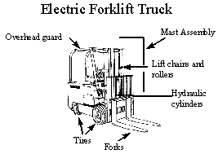

DAILY INSPECTION CHECKLIST  Propane Forklift Truck  KEY OFF Procedures  - The vehicle inspection  - Overhead guard  - Hydraulic cylinders  - Mast assembly  - Lift chains and rollers  - Forks  - Tires  - LPG tank and locator pin  - LPG tank hose  - Gas gauge  - Check the engine oil level  - Examine the battery  - Check the hydraulic fluid level  - Check the engine coolant level  KEY ON Procedures  - Test the front, tail, and brake lights  ENGINE RUNNING Procedures  - Check the gauges  - Oil pressure indicator lamp  - Ammeter indicator lamp  - Hour meter  - Water temperature gauge  - Test the standard equipment  - Steering  - Brakes  - Horn  - Safety seat (if equipped)  - Check the operation of load-handling attachments  - Check the transmission fluid level | 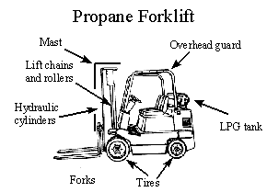

DAILY INSPECTION CHECKLIST  Yard Forklift Truck  KEY OFF Procedures  - The vehicle inspection  - Overhead guard  - Hydraulic cylinders  - Mast assembly  - Lift chains and rollers  - Forks  - Tires  - LPG tank and locator pin  - LPG tank hose  - Gas gauge  - Check the engine oil level  - Examine the battery  - Inspect the hydraulic fluid level  - Check the engine coolant level  KEY ON Procedures  - Test the standard equipment  - Front, tail, and brake lights  - Fuel gauge (if diesel)  - Windshield wiper  - Heater  ENGINE RUNNING Procedures  - Check the gauges  - Oil pressure indicator lamp  - Ammeter indicator lamp  - Ammeter  - Hour Meter  - Water Temperature Gauge  - Test the standard equipment  - Steering  - Brakes  - Horn  - Safety seat (if equipped)  - Check the operation of load-handling attachments  - Check the transmission fluid level | 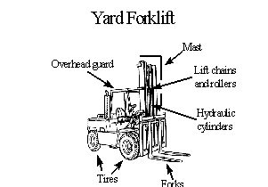

DAILY INSPECTION CHECKLIST  Electric Transtacker  KEY OFF Procedures  - The vehicle inspection  - Overhead guard  - Hydraulic cylinders  - Mast assembly  - Lift chains and rollers  - Forks  - Tires  - Battery cables  - Safety door  KEY ON Procedures  - Check the gauges  - Battery discharge indicator  - Hour meter  - Test the standard equipment  - Steering Brakes  - Lights  - Horn  - Test the control lever  - Check the operation of load-handling attachments | 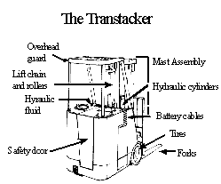

DAILY INSPECTION CHECKLIST  Riding Grip Tow  - The vehicle inspection  - Lines and hoses  - Battery  - Safety switch  - Hand guards  - The operations inspection  - Test the brakes  - Check the drive operations  - Test the horn  - Check the grip coupling  DAILY INSPECTION CHECKLIST  Stand-up Riding Tow Tractor  - The vehicle inspection  - Lines and hoses  - Battery  - Safety switch  - Hand guards  - The operations inspection  - Test the brakes  - Check the drive operations  - Test the horn  - Check the tow hook and safety catch | Riding Grip Tow  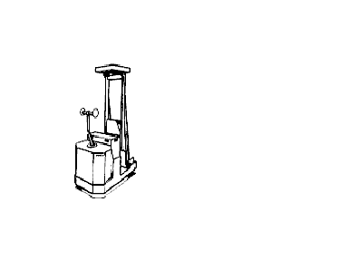  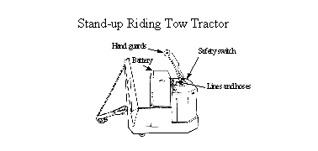

DAILY INSPECTION CHECKLIST  Walking Pallet Truck  - The vehicle inspection  - Forks  - Battery  - Hand guards  - The operations inspection  - Check the drive operations  - Test the brakes  - Check the horn  - Inspect the load-handling attachment operations  DAILY INSPECTION CHECKLIST  Walking Transtacker  - The vehicle inspection  - Forks  - Battery  - Hand guards  - The operations inspection  - Check the drive operations  - Test the brakes  - Check the horn  - Inspect the load-handling attachment operations | 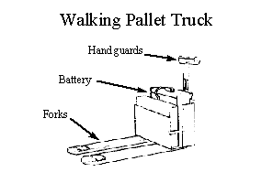  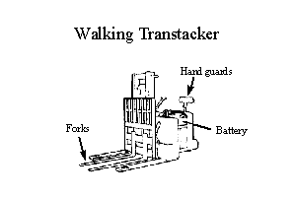

DAILY INSPECTION CHECKLIST  Indoor Propane Tow Tractor  KEY OFF Procedures  - The vehicle inspection  - Fluid leakage  - Tires  - Tow hook  - Windshield (if equipped)  - Overhead guard (if equipped)  - LPG tank and locator pin  - LPG tank hose  - Gas gauge  - Check the engine oil level  - Check the engine coolant level  - Examine the battery  KEY ON Procedures  - Test the front, tail, and brake lights  - Check the gauges  - Oil pressure gauge  - Ammeter  - Water temperature gauge  - Hour meter  ENGINE RUNNING Procedures  - Inspect the standard equipment  - Steering  - Brakes  - Horn  - Safety seat (if equipped)  - Check the transmission fluid level | 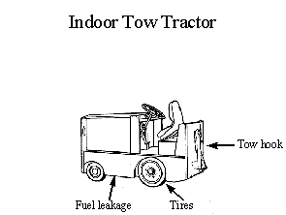

DAILY INSPECTION CHECKLIST  Industrial Tractors  KEY OFF Procedures  - The vehicle inspection  - Windshield  - Tires  - Three-point hitch assembly  - Engine oil  - Engine coolant  KEY ON Procedures  - Check gauges  - Oil and battery lights  - Temperature  - Hour meter  - Standard equipment  - Steering  - Front, tail, and brake lights  - Horn  ENGINE RUNNING Procedures  - Standard equipment  - Windshield wiper  - Brakes  - Hoist operation | 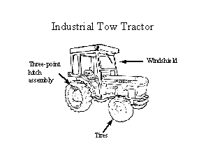

DAILY INSPECTION CHECKLIST  Reach Truck  KEY OFF Procedures  - The vehicle inspection  - Overhead guard  - Hydraulic cylinders  - Mast assembly  - Lift chains and rollers  - Forks  - Tires  - Battery cables  - Safety door  - Hydraulic fluid  KEY ON Procedures  - Check the gauges  - Battery discharge indicator  - Hour meter  - Test the standard equipment  - Steering  - Brakes  - Lights  - Horn  - Test the control lever  - Check the operation of load-handling attachments | 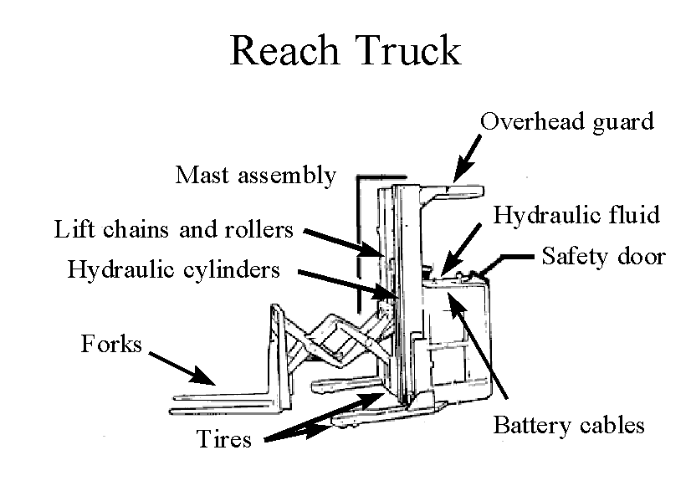

DAILY INSPECTION CHECKLIST
Order Picker
KEY OFF Procedures
- The vehicle inspection
  - Hoist lines, cables, and chains
  - Hour meter
  - Tires
  - Battery cables
  - Limiting device
KEY ON Procedures
- Check the battery discharge indicator
- Test the standard equipment
  - Safety interlock
  - Steering
  - Brakes
  - Lights
  - Horn
- Check the accessories
  - Gripper jaws
  - Work platform

SAMPLE GENERIC CHECKLIST
FOR POWERED INDUSTRIAL TRUCKS

Overhead Guard - Are there broken welds, missing bolts, or damaged areas?
Hydraulic Cylinders - Is there leakage or damage on the lift, tilt, and attachment functions of the cylinders?
Mast Assembly - Are there broken welds, cracked or bent areas, and worn or missing stops?
Lift Chains and rollers
Is there wear or damage or kinks, signs of rust, or any sign that lubrication is required?
Is there squeaking?
Forks
Are they cracked or bent , worn, or mismatched?
Is there excessive oil or water on the forks?
Tires - What do the tires look like?
Are there large cuts that go around the circumference of the tire?
Are there large pieces of rubber missing or separated from the rim?
Are there missing lugs?
Is there bond separation that may cause slippage?
Battery Check
Are the cell caps and terminal covers in place?
Are the cables missing insulation?
Hydraulic Fluid - Check level?
Gauges - Are they all properly working?
Steering
Is there excessive free play?
If power steering, is the pump working?
Brakes
If pedal goes all the way to the floor when you apply the service brake, that is the first indicator that the brakes are bad. Brakes should work in reverse, also.
Does the parking brake work? The truck should not be capable of movement when the parking brake is engaged.
Lights - If equipped with lights, are they working properly?
Horn - Does the horn work?
Safety seat - if the truck is equipped with a safety seat is it working?
Load Handling Attachments
Is there hesitation when hoisting or lowering the forks, when using the forward or backward tilt, or the lateral travel on the side shift?
Is there excessive oil on the cylinders?
Propane Tank - Is the tank guard bracket properly positioned and locked down?
Propane Hose
Is it damaged? It should not be frayed, pinched, kinked, or bound in any way.
Is the connector threaded on squarely and tightly?
Propane Odor - If you detect the presence of propane gas odor, turn off the tank valve and report the problem.
Engine Oil - Check levels.
Engine Coolant - Visually check the level. Note: Never remove the radiator cap to check the coolant level when the engine is running or while the engine is hot. Stand to the side and turn your face away. Always use a glove or rag to protect your hand.
Transmission Fluid - Check levels?
Windshield Wipers - Do they work properly?
Seat Belts - Do they work?
Safety Door - (found on stand up rider models) Is it in place?
Safety Switch - (found on stand up riding tow tractors) Is it working?
Hand guards - (found on stand up riding tow tractors, walking pallet trucks, walking transtackers) Are they in place?
Tow Hook
Does it engage and release smoothly?
Does the safety catch work properly?
Control Lever - Does the lever operate properly?
Safety Interlock - (found on order pickers) If the gate is open, does the vehicle run?
Gripper Jaws - (found on order pickers) Do the jaws open and close quickly and smoothly?
Work Platform - (found on order pickers) Does the platform raise and lower smoothly?

